# *Lab manual 9*

## Name: Muhammad Usman Bhutto.

## Roll no: 453891

## Section: B

## Lab task 1:

#include<iostream>

using namespace std;

int main()

{

int arr[3][3],sum;

cout<<" enter values of matrix:";

for(int i=0;i<3;i++){

for(int j=0;j<3;j++)

cin>>arr[i][j];

}

for(int i=0;i<3;i++){

for(int j=0;j<3;j++){

if(i==j || i+j==2){

sum+=arr[i][j];

}

}

}

cout<<"the sum of left and right diagonal is:"<<sum<<endl;

return 0;

}

## Output:

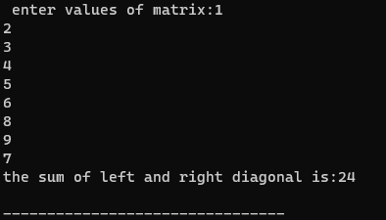

## Lab task 2:

#include<iostream>

using namespace std;

int main(){

int a[3][3],b[3][3],sum[3][3];

cout<<"enter the values of first matrix:";

for(int i=0;i<3;i++){

for(int j=0;j<3;j++)

cin>>a[i][j];

}

cout<<"enter the values of second matrix:";

for(int i=0;i<3;i++){

for(int j=0;j<3;j++)

cin>>b[i][j];

}

for(int i=0;i<3;i++){

for(int j=0;j<3;j++){

sum[i][j]=a[i][j]+b[i][j];

}

}

cout<<"sum of two matrix:"<<endl;

for(int i=0;i<3;i++){

for(int j=0;j<3;j++){

cout<<sum[i][j]<<" ";

}

cout<<"\n";

}

return 0;

}

## Output:

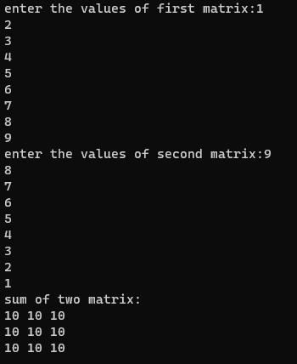

## Lab task 3:

#include<iostream>

using namespace std;

int main()

{

int arr[3][3],transpose[3][3];

cout<<"enter values of matrix:";

for(int i=0;i<3;i++){

for(int j=0;j<3;j++)

cin>>arr[i][j];

}

cout<<"the matrix is:"<<endl;

for(int i=0;i<3;i++){

for(int j=0;j<3;j++){

cout<<arr[i][j]<<" ";

}

cout<<"\n";

}

for(int i=0;i<3;i++){

for(int j=0;j<3;j++){

transpose[j][i]=arr[i][j];

}

}

cout<<"the matrix after transpose is:"<<endl;

for(int i=0;i<3;i++){

for(int j=0;j<3;j++){

cout<<transpose[i][j]<<" ";

}

cout<<"\n";

}

}

## Output:

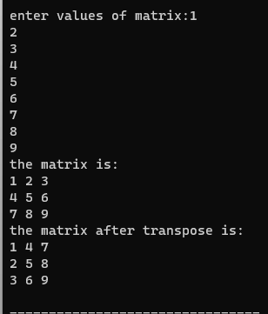

## Lab task 4:

#include <iostream>

void multiplyMatrix(int mat1[3][3], int mat2[3][3], int result[3][3]) {

for (int i = 0; i < 3; ++i) {

for (int j = 0; j < 3; ++j) {

result[i][j] = 0;

for (int k = 0; k < 3; ++k) {

result[i][j] += mat1[i][k] * mat2[k][j];

}

}

}

}

int main() {

using namespace std;

int matrix1[3][3], matrix2[3][3], resultMatrix[3][3];

cout << "Enter elements of the first matrix (row-wise):" << endl;

for (int i = 0; i < 3; ++i) {

for (int j = 0; j < 3; ++j) {

cout << "Enter element at position " << i + 1 << "," << j + 1 << ": ";

cin >> matrix1[i][j];

}

}

cout << "Enter elements of the second matrix (row-wise):" << endl;

for (int i = 0; i < 3; ++i) {

for (int j = 0; j < 3; ++j) {

cout << "Enter element at position " << i + 1 << "," << j + 1 << ": ";

cin >> matrix2[i][j];

}

}

multiplyMatrix(matrix1, matrix2, resultMatrix);

cout << "Resultant Matrix (after multiplication):" << endl;

for (int i = 0; i < 3; ++i) {

for (int j = 0; j < 3; ++j) {

cout << resultMatrix[i][j] << "\t";

}

cout << endl;

}

return 0;

}

## Output:

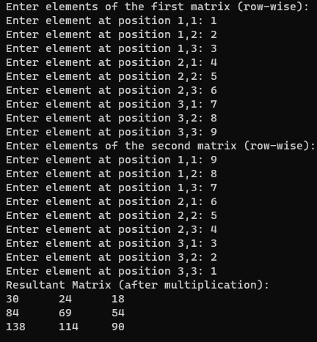

## Lab task 5:

#include <iostream>

void printTable(int number, int multiplier) {

if (multiplier > 10) {

return;

}

std::cout << number << " x " << multiplier << " = " << (number * multiplier) << std::endl;

printTable(number, multiplier + 1);

}

int main() {

using namespace std;

int tableNumber = 15;

cout << "Multiplication table of " << tableNumber << ":" << endl;

printTable(tableNumber, 1);

return 0;

}

## Output:

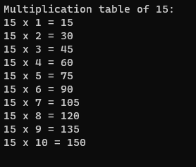

## Home task:

#include<iostream>

using namespace std;

int main(){

int mat[3][3], i, j;

float determinant = 0;

cout<<"Enter elements of matrix row wise:\n";

for(i = 0; i < 3; i++)

for(j = 0; j < 3; j++)

cin>>mat[i][j];

printf("\nGiven matrix is:");

for(i = 0; i < 3; i++){

cout<<"\n";

for(j = 0; j < 3; j++)

cout<<mat[i][j]<<"\t";

}

//finding determinant

for(i = 0; i < 3; i++)

determinant = determinant + (mat[0][i] * (mat[1][(i+1)%3] * mat[2][(i+2)%3] - mat[1][(i+2)%3] * mat[2][(i+1)%3]));

cout<<"\n\ndeterminant: "<<determinant;

cout<<"\n\nInverse of matrix is: \n";

for(i = 0; i < 3; i++){

for(j = 0; j < 3; j++)

cout<<((mat[(j+1)%3][(i+1)%3] * mat[(j+2)%3][(i+2)%3]) - (mat[(j+1)%3][(i+2)%3] * mat[(j+2)%3][(i+1)%3]))/ determinant<<"\t";

cout<<"\n";

}

return 0;

}

## Output:

